**Creating Data Warehouse for Chinook in SQLserver and MySQL database**

🡪 **SQL Server**

Created Dimensional Data model in Toad Data Modeler for SQL server

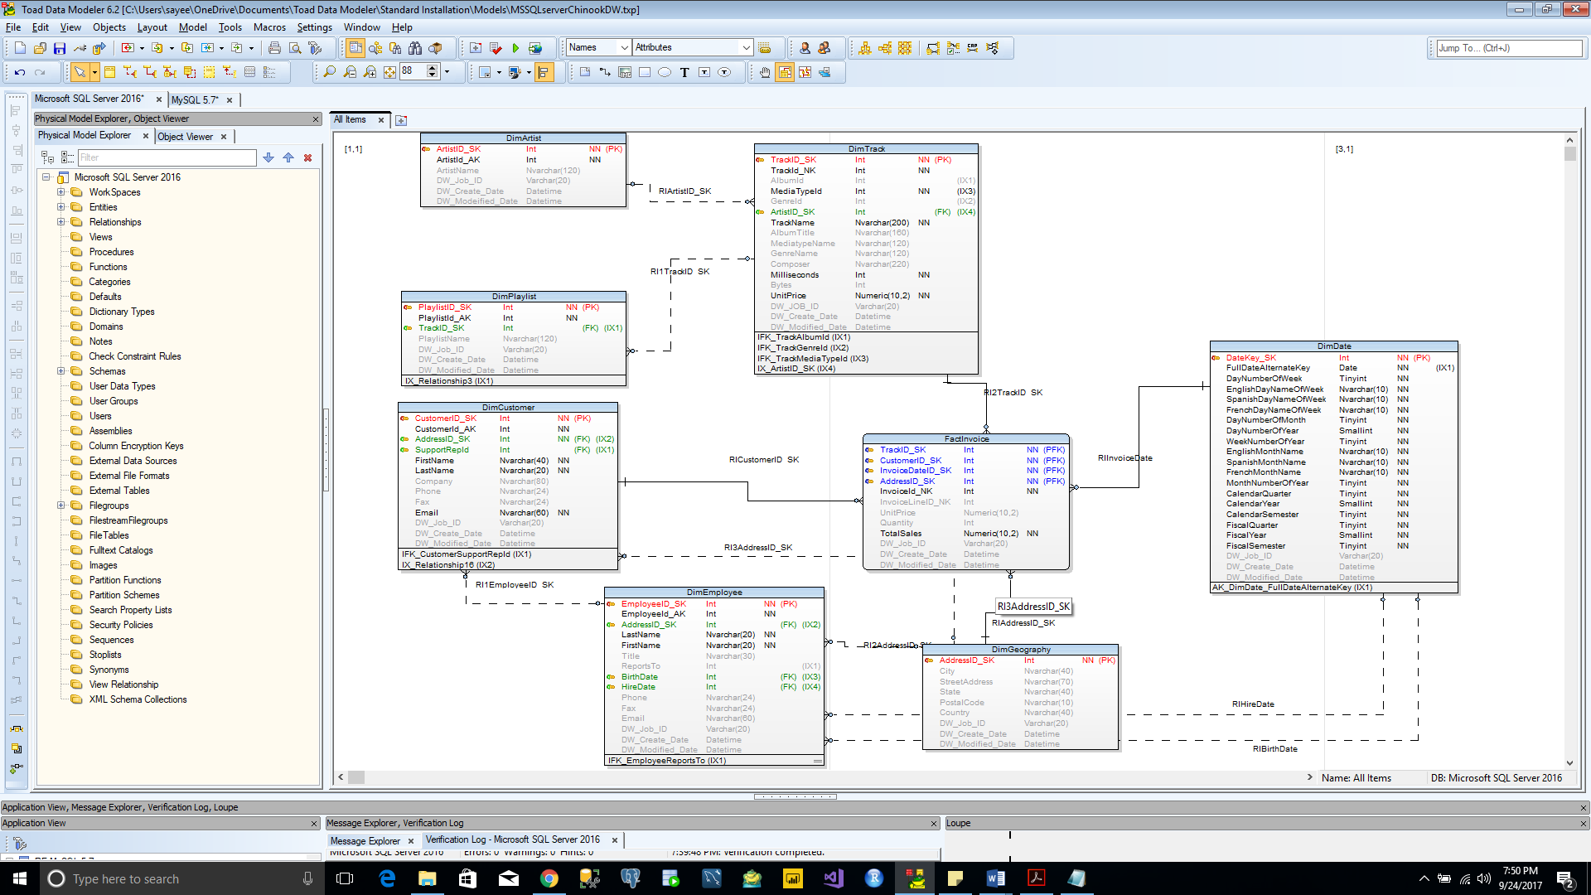

Generated the SQL script for SQL server database

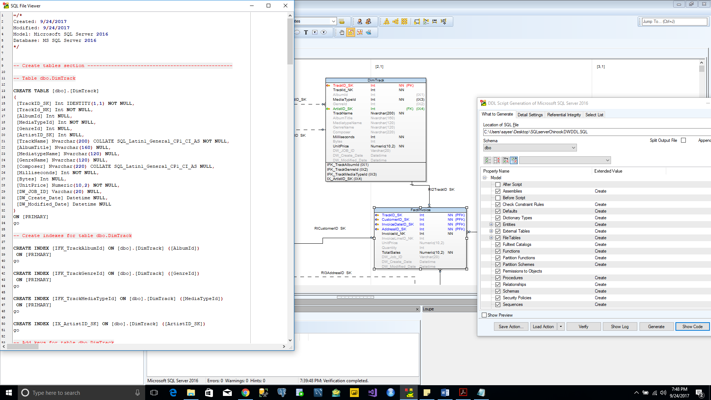

Impleted the SQL script in SQL server and created the Chinook DW

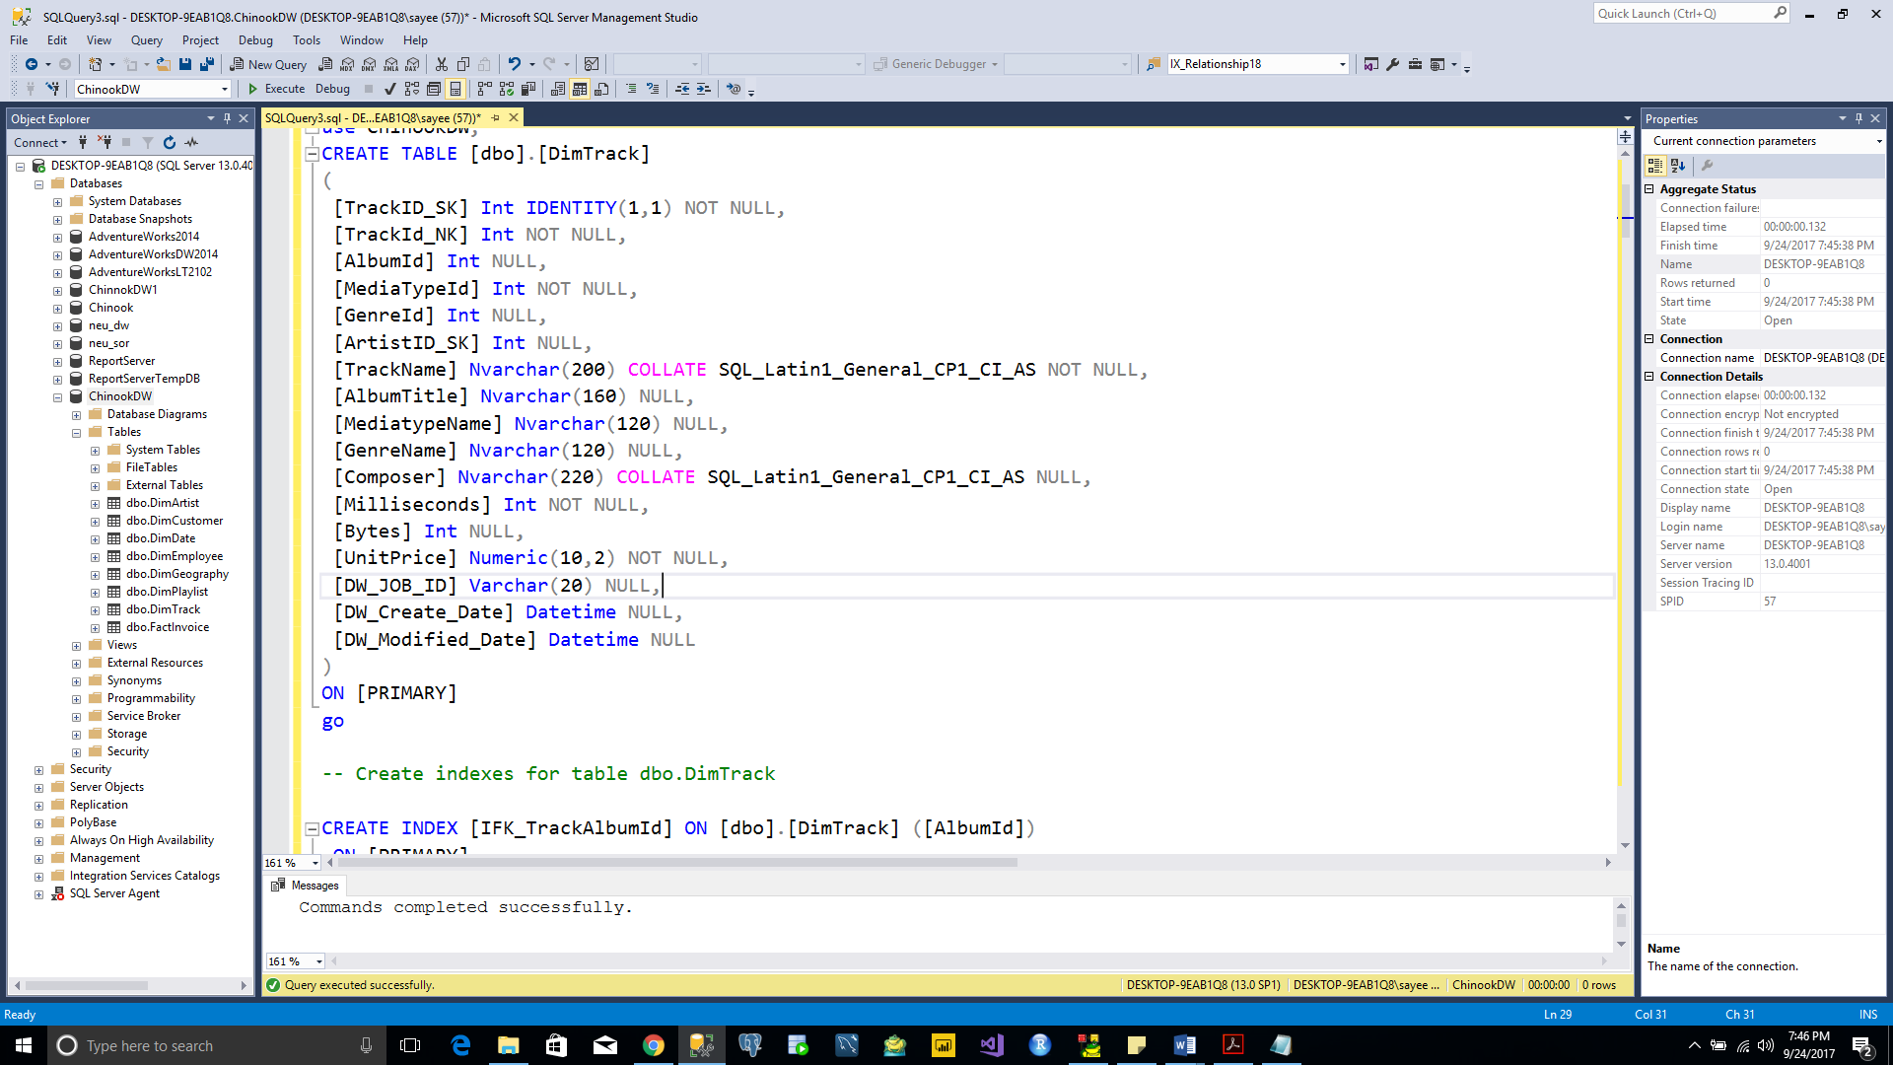

🡪 **MYSQL**

Created Dimensional Data model in Toad Data Modeler for MySQL

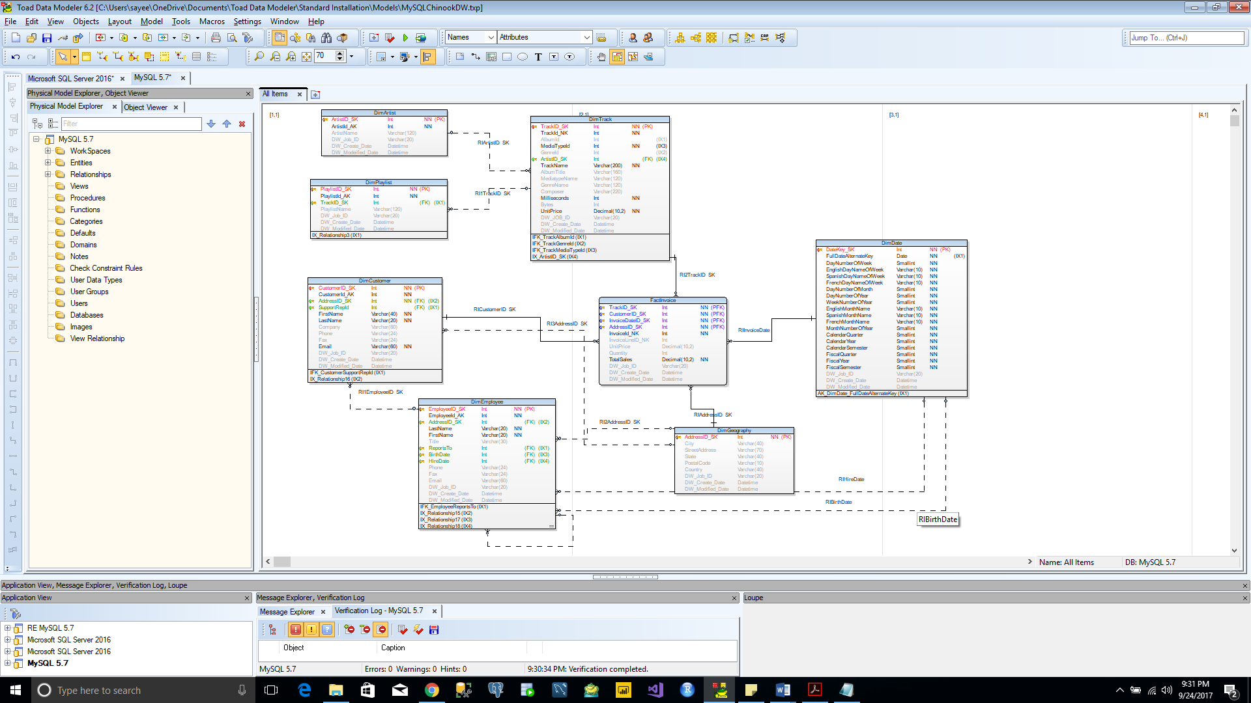

Generated the SQL script for MySQL database

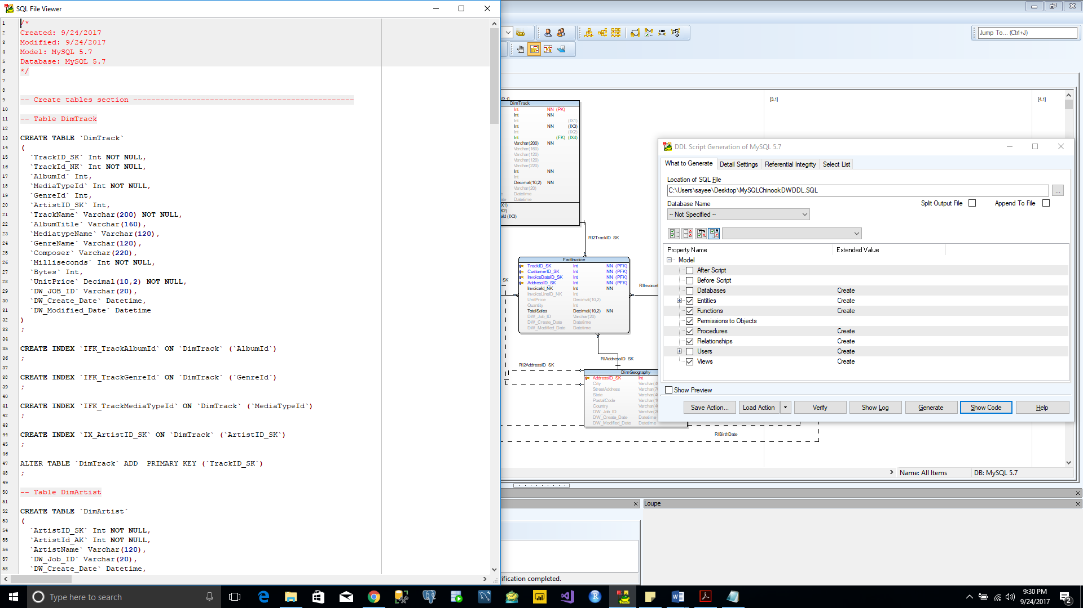

Impleted the SQL script in MySQL and created the Chinook DW

